

Detecting Responses in Chat Messages

Name: Safi Ullah (04072113001)
Semester: 5th
Subject: CS-414 (Artificial Intelligence)
Submitted To: Dr. Ayaz Hussain
Project Report: Detecting Responses in Chat Messages

Introduction
In this report, we present our analysis and findings related to the problem of detecting responses in chat messages. The goal of this project is to design a linear predictor that can determine if the second message in a chat is a response to the first message. We have collected a dataset of chat messages from “My WhatsApp” and used it for training and evaluation.

Data Collection
- We collected chat message data from” My WhatsApp” to create a dataset.
- The dataset contains 101 training examples, ensuring enough data for our analysis.
- We have taken measures to ensure that the dataset does not contain any private or sensitive information.

Linear Predictor Development
- In the development of our linear predictor, we utilized the sigmoid function to compute the loss and its derivative, which is a common approach in logistic regression for binary classification problems.

- We formulated the loss function as the negative log-likelihood loss, which is based on the sigmoid function's output. The loss function for our binary classification problem can be expressed as follows:

def sigmoid_loss(w):
z = np.dot(X, w)
y_pred = 1 / (1 + np.exp(-z))
loss = -y * np.log(y_pred) - (1 - y) * np.log(1 - y_pred)
return loss.mean()

- To minimize the loss function, we used gradient descent, where the gradient was calculated as the difference between the predicted probabilities (output of the sigmoid function) and the true labels.

def sigmoid_loss_derivative(w):
z = np.dot(X, w)
y_pred = 1 / (1 + np.exp(-z))
gradient = np.dot(X.T, y_pred - y) / len(y)
return gradient

def gradientDescent(sigmoid_loss, sigmoid_loss_derivative, d):
w = np.zeros(d)
eta = 0.01
losses=[]
for t in range(2000):
value = sigmoid_loss(w)
gradient = sigmoid_loss_derivative(w)
w = w - eta * gradient
losses.append(value)
print('iteration {}: w = {}, F(w) = {}'.format(t, w, value))

return w, losses

- We conducted experiments with different numbers of iterations to optimize the model's parameters (i.e., the weight vector W).

Learning Curve Analysis
- We conducted experiments with different numbers of iterations and step sizes to understand the behaviour of the linear predictor.
- We plotted learning curves to visualize how the loss changes as we vary the number of iterations.
- We compared the learning curves for different step sizes to analyze the effect of step size on convergence.

For eta= 0.01 and no_of_itrations= 1000, the learning curve is

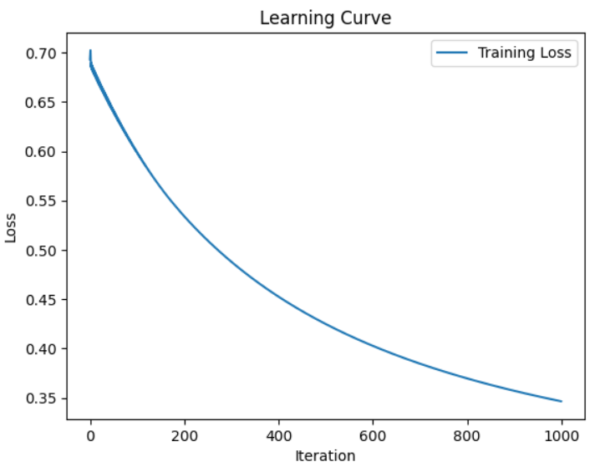

For eta= 0.02 and no_of_itrations= 1000, the learning curve is

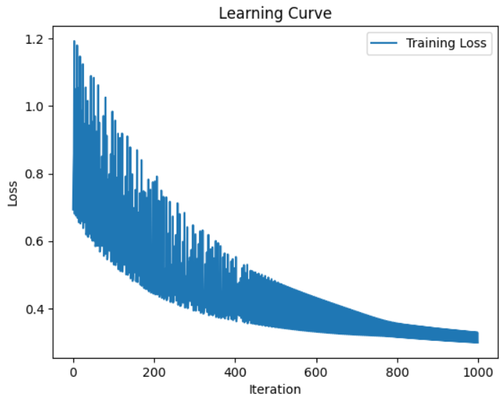

For eta= 0.01 and no_of_itrations=2000, the learning curve is

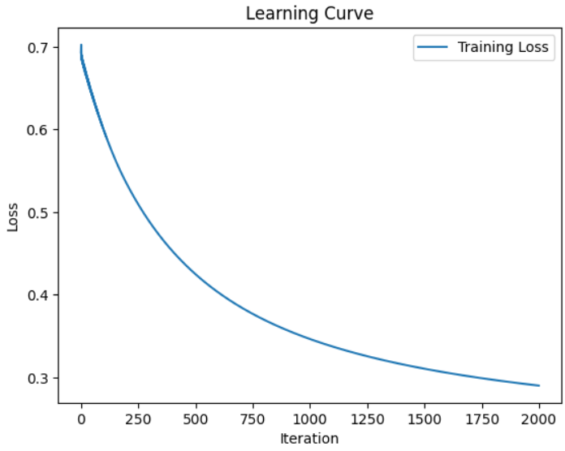

For eta= 0.02 and no_of_itrations= 2000, the learning curve is

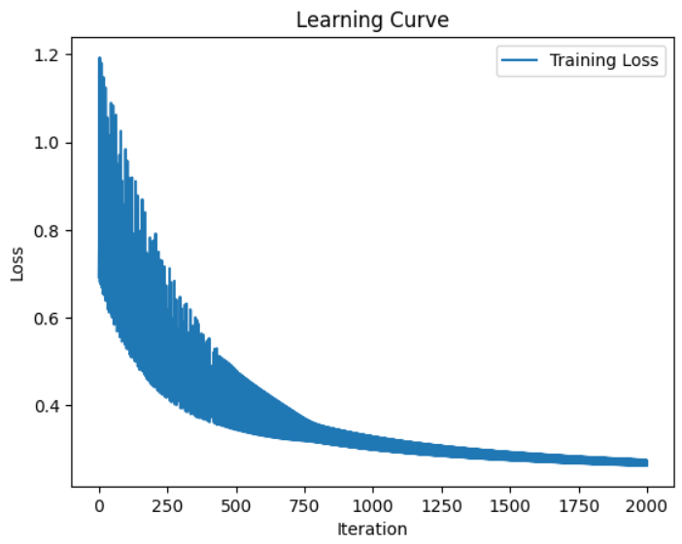

The accuracy of above model: 0.9

Built-In Linear Predictor
- In addition to our custom linear predictor, we also utilized the built-in linear predictor function available in Python (e.g., scikit-learn's Logistic Regression).
- We ran similar experiments and plotted learning curves for the built-in model.
- This allowed us to compare the performance of our custom predictor with the built-in solution.

For no_of_itration= 1000, learning curve is

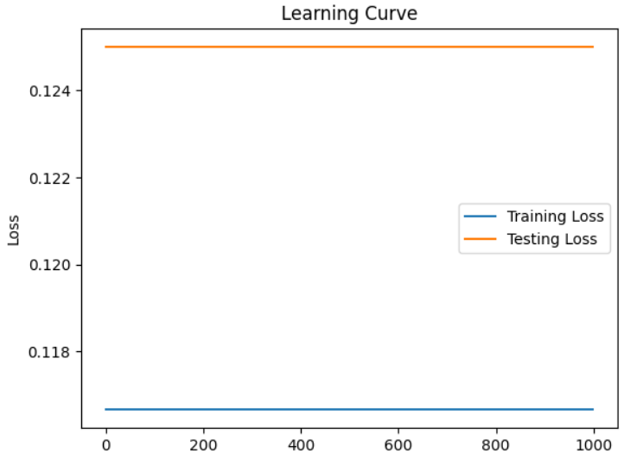

For no_of_itration= 2000, learning curve is

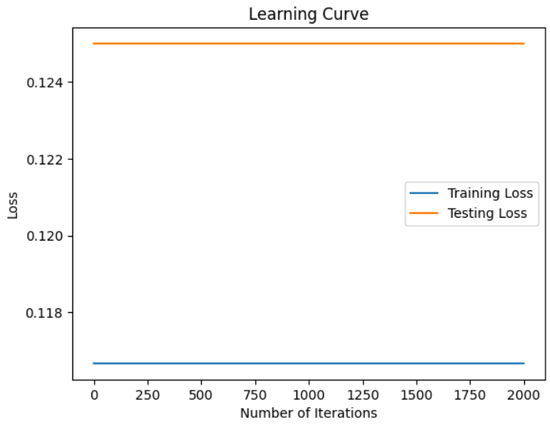

The accuracy of built-in Logistic Regression model: 0.9

Results and Findings
If we compare the learning curves of built-in predictor and my predictor, it is clearly shown that the learning curve of built-in model is better. But if we compare the accuracy of two models then it is same. So, it is concluded that my predictor is also predicting same as the built-in predictor.

